Setting up the FirstClass Client at Home

Downloading the FirstClass client allows you to get an identical FirstClass experience to that at school.

If you have already downloaded and installed the client software, skip to step #3.

- Download the client software at http://sch.ci.lexington.ma.us/. Click to download the FirstClass client. Choose the appropriate operating system.
- Run the installer. When the installer is finished, open the FirstClass application. The screen below should appear:
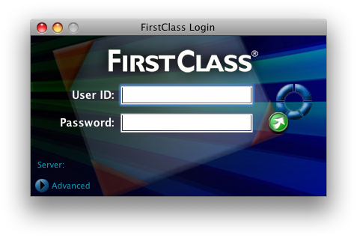
- Click the “Advanced” tab (highlighted above). The screen should expand to reveal more options, as shown below.
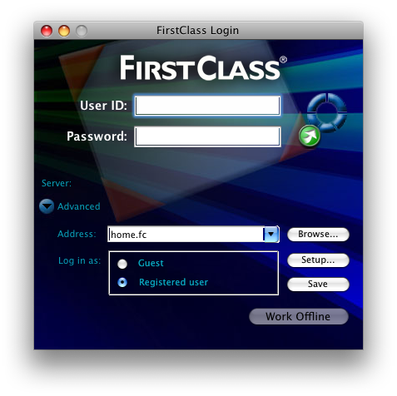
- Click the “Setup” button, highlighted above. The screen shown below should appear:
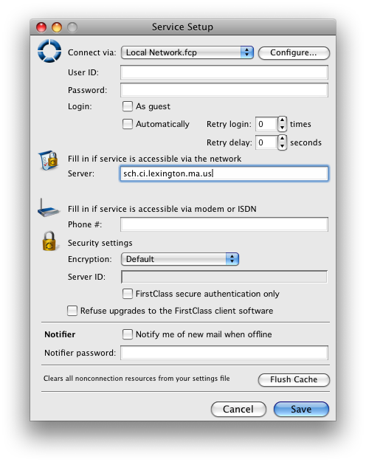
- Type “sch.ci.lexington.ma.us” (without quotes) into the “Server” field (highlighted above). If you wish, type your username into the appropriate field (highlighted above) to automatically fill it in when you open FirstClass.

- Click “Save” to save the settings.

Troubleshooting:

If you do not succeed in logging in after following these instructions, make sure you are entering your username and password correctly. Make sure you are entering your username and not your email address. Faculty usernames generally take the form firstinitiallastname (i.e. jsmith for Joe Smith). Student usernames generally take the form lastnamefirstname (i.e. smithjoe for Joe Smith). Also make sure you are spelling the password correctly and using the correct case as passwords are case-sensitive (uppercase and lowercase letters must be entered exactly as assigned).

